A+ Computer Science THE LOCKUP

Lab Goal: To analyze a problem and determine how to break it into smaller tasks and then create the needed methods to solve it. You must plan each method based on preconditions as well as post conditions. When finished, the flowers and fences will all be gone.

Lab Description: Determine the number of methods needed for Angela to remove all the flowers, remove all the fences, and then make the run to freedom. When the fences are all gone – Angela’s 3 friends will be free to join her in running free. She must start her quest with no flowers. She will also end her quest with no flowers. All the other Jeroos will join her in fleeing to the East.

Start Screen:
Files Needed ::
lockup.jsc
lockup.jev

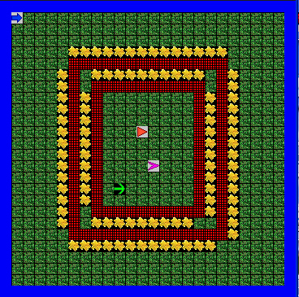
algorithm help

Analyze – what tasks do I need to do.

What must each method accomplish?

How many methods do I need?

Do I need loops?

Preconditions –
- Where do I start

Postcondition –
- Flowers are completely gone.
- Nets are completely gone.
- All Jeroos are facing the Water
- All Jeroos are facing the East.

Ending Screen:

